

**PROJECT REPORT**

# Coffee Shop Management

|  |  |
| --- | --- |
| **Semester:** | Programming Fundamentals |
| **Class:** | PF1121 |
| **Group:** | Không chỉ 2 môn đâu |
| **Instructor** | Nguyen Xuan Sinh |
| **Team members:** | Nguyen Ngoc Duc  Nguyen Thi Khanh Ly |

# Index

Project Name 1

Index 2

I. Project introduction 3

II. Analyze System Requirements 3

III. Design Details 8

IV. Test 14

V. Task Assign (to each team member) 15

VI. Installation Instructions 16

Appendix 17

Document format 18

# Project introduction

Briefly describe the operation of the system to which the project will be applied

The system helps to manage the coffee shop. Will provide some basic features including:

* Login staff account.
* Oder management, create, edit, complete, cancel order.
* Check out.

Which includes additional features such as view order list, view order details, view product list, revenue statistic.

1. Proposed System

* Creating a program to staff create order, confirm payment or cancel order.
* Creating a program to staff check out, revenue statistic during the shift.

1. The scope of the project to be applied

* Make for actor are staff.

1. System Name

* Coffee shop management.

1. Deployment Environment

* Windows, Linux, Mac.

1. Development Tools

* Visual Studio Code
* Draw.io Diagram
* MySQL Workbench 8.0 CE

1. Customer Requirements (System features)

* Staff login.
* Show menu.
* Create order.
* Show order.
* Show order details.
* Complete order and cancel order.

# Analyze System Requirements

This system was created to help coffee shop manage orders easily. It can help the staff to have more information about the coffees sold in the store, that information can include price, name, status. The main function of this system for the staff is that it helps the staff to create the order according to the buyer’s request, allow them to view the information of unpaid order and confirm successful payment if enough money has been received from the buyer, cancel the order when the buyer changes his mind or pause payment in case of necessity.

1. Use Case
   1. Use Case

------------------------------------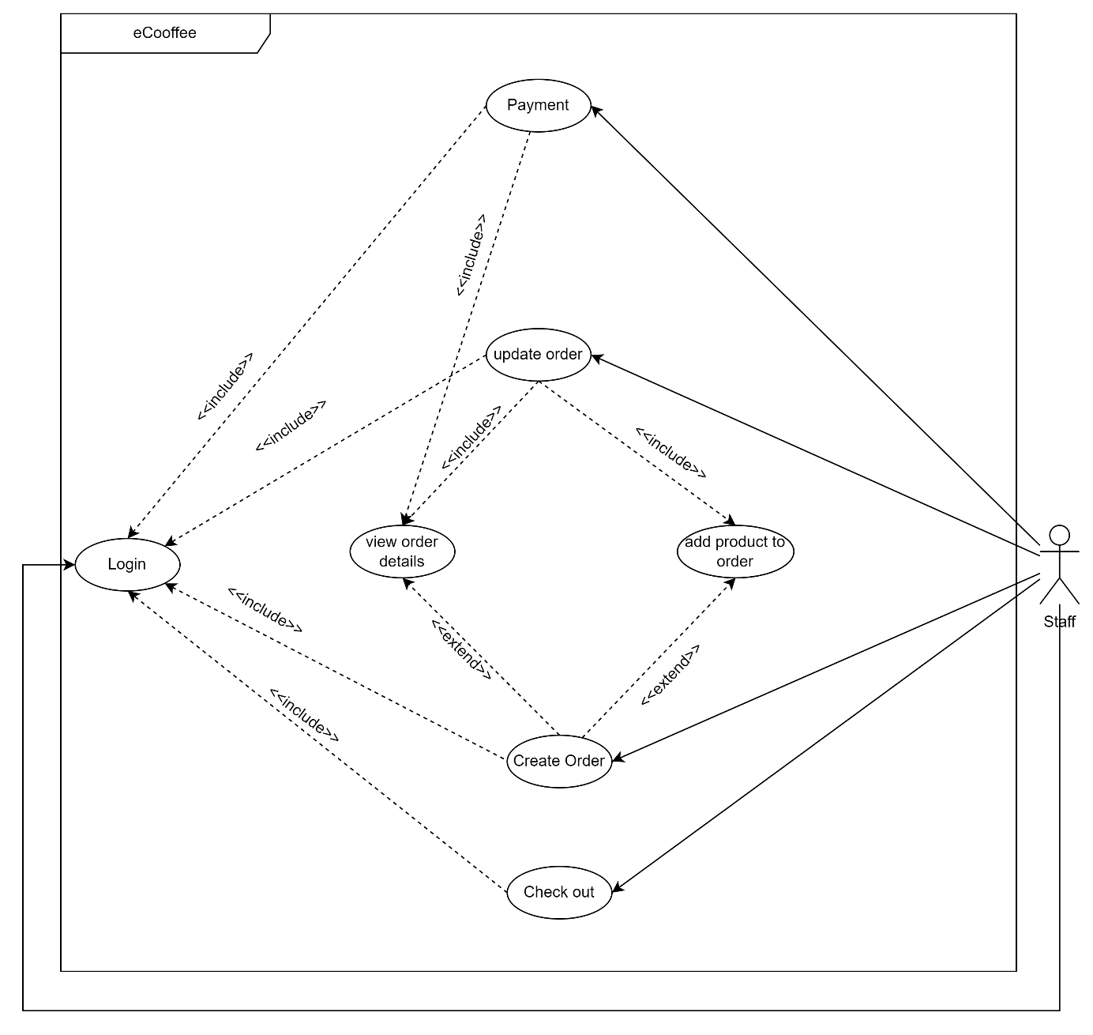

* 1. Login description

|  |  |
| --- | --- |
| Use Case Name | Login |
| Use Case ID | UC_Login |
| Description | Used to access the program and use system. |
| Actor | Staff |
| Organizational Benefits | The feature was created to define the features and data that staff can access in the program. |
| Triggers | Login will be automatically activated as soon as we start the program. |
| Preconditions | Must enter the correct username and password, database must be connected, account must be made available. |
| Postconditions | Success: Staff have logged into the system, the main menu of the program must be displayed.  Fail: Staff haven’t logged into the system. |
| Main Course | Step 1: Input username and password.  Step 2: Verify login.  Step 3: Show main menu. |
| Alternate Courses | AC 1: Username and password exists.  Step 1: Show successful login message.  Step 2: Show main menu |
| Exceptions | EX 1: User enter wrong username, password  Step 1: Display message error.  Step 2: Show the login screen again.  Step 3: Re-enter request.  EX 2: Enter invalid user name or password (special character or invalid structure)  Step 1: Display message error.  Step 2: Show the login screen again.  Step 3: Re-enter request.  EX 3: Input only username or password  Step 1: Display “Please enter both account and password”.  Step 2: Request to re-enter username and password.  EX 3: Disconnect to database  Step 1: Display “Database is disconnected, please check your internet.”  Step 2: Request to check connection. |

* 1. Add product to order description

|  |  |
| --- | --- |
| Use Case Name | Add product to order |
| Use Case ID | UC_AddProduct |
| Description | Used to add product to order |
| Actor | Staff |
| Organizational Benefits | You can check valid properties of product (id, quantity, instock) and add product to order if product is valid. |
| Triggers | This feature will be activated in create order feature, update order feature. |
| Preconditions | The functions to create order or update order is selected and a product must be selected. |
| Postconditions | Success: Add product complete  Fail: Add product not complete. |
| Main Course | 1. Input product id and quantity you want to order. 2. Valid data. 3. Add product complete. |
| Alternate Courses | AC 1: Add product or update complete.  Step 1: Show success message.  AC 2: Exit (choose 0)  Step 1: Show main menu if there are no products in order or show order details if products already in order. |
| Exceptions | EX 1: Invalid product id (input special character or alphanumeric character, id not exits in menu)  Step 1: Display message error.  Step 2: Request re-entry.  EX 2: Invalid quantity (input special character or alphanumeric character).  Step 1: Display message error.  Step 2: Request re-entry.  EX 3: Selected product is out of stock.  Step 1: Show out of stock message.  Step 2: Request to choose another product.  EX 4: The selected product does not have the required quantity.  Step 1: Show message error.  Step 2: Request to re-entry quantity or change product.  Step 2.1 (re-entry quantity): Display request input quantity.  Step 2.2 (change product): delete selected product and request choose another product.  EX 5: Disconnect to database.  Step 1: Display “Database is disconnected, please check your internet.”  Step 2: Request to check connection. |

* 1. Create order description

|  |  |
| --- | --- |
| Use Case Name | Create Order |
| Use Case ID | UC_CreateOrder |
| Description | Used to create order. |
| Actor | Staff |
| Organizational Benefits | You can create one or more orders according to customer’s request. |
| Triggers | This feature will be activated when staff use choose it in main menu. |
| Preconditions | Must have at least one product previously created. |
| Postconditions | Success: Create order complete.  Fail: Create order not complete. |
| Main Course | 1. Show menu and request to add product to order. 2. Valid data and 3. Confirm request. 4. Create order complete. |
| Alternate Courses | AC 1: Continue add product to order.  Step 1: After adding a product to order, display message “Do you want to continue add product to order?”.  Step 2: Choose Yes.  Step 3: Show menu and ask to add again. |
| Exceptions | EX 1: Cancel order before confirming.  Step 1: After selecting the product and quantity, show message “Do you want to confirm the order?”.  Step 2: Choose No.  Step 3: Show canceled order and delete order.  EX 2: Invalid choice (input special character or alphanumeric character or other choice in menu)  Step 1: Display message error.  Step 2: Request re-entry.  EX 3: Disconnect to database.  1. Step 1: Display “Database is disconnected, please check your internet.”  2. Step 2: Request to check connection. |

* 1. Update order description

|  |  |
| --- | --- |
| Use Case Name | Update order |
| Use Case ID | UC_UpdateOrder |
| Description | Used to update order. |
| Actor | Staff |
| Organizational Benefits | You can update order information. |
| Triggers | Login to program to use this feature. |
| Preconditions | The order must be exist. |
| Postconditions | Success: Update order complete.  Fail: Update order not complete. |
| Main Course | 1. Select the order you want to view details in list all order. 2. If order valid, Show all order information. |
| Alternate Courses | AC 1: Add product to current order.   1. Show menu and ask to choose product you want to add to order. 2. Add product to order, show complete message and ask to continue add.   AC 2: Update product information.   1. Show list product in order. 2. Choose product in order. 3. Update product order, show complete message and ask to continue update.   AC 3.1: Remove product.   1. Show list product in order and ask to choose product. 2. Remove product, show complete message and ask to continue remove.   AC 3.2: Confirm product in order.   1. Show list product in order and ask to choose product. 2. Confirm product and ask to continue confirm. |
| Exceptions | EX 1: The select order does not exist.  Step 1: Display “Order does not exist, Please select the order form the list. ”  Step 2: Request to choose order again.  EX 2: Disconnect to database.  Step 1: Display “Database is disconnected, please check your internet.”  Step 2: Request to check connection.  EX 3: Invalid choice (input special character or alphanumeric character or other choice in menu)  Step 1: Display message error.  Step 2: Request re-entry. |

* 1. Payment description

|  |  |
| --- | --- |
| Use Case Name | Payment |
| Use Case ID | UC_Payment |
| Description | Used to payment confirmation. |
| Actor | Staff |
| Organizational Benefits | You can confirm payment. |
| Triggers | Login to program to use this feature. |
| Preconditions | The order must be exist. |
| Postconditions | Success: Confirm payment complete.  Fail: Confirm payment not complete . |
| Main Course | 1. Select the order you want to payment in list all order. 2. If order valid, Show order information and total amount . 3. Confirm payment |
| Alternate Courses | AC1: Confirm payment.   1. Request confirm. 2. Confirm complete.   AC2: Not confirm payment.   1. Request confirm. 2. Choose 0. 3. Back to list order. |
| Exceptions | EX 1: The select order does not exist.  Step 1: Display “Order does not exist, Please select the order form the list. ”  Step 2: Request to choose order again.  EX 2: Disconnect to database.  Step 1: Display “Database is disconnected, please check your internet.”  Step 2: Request to check connection.  EX 3: Invalid choice (input special character or alphanumeric character or other choice in menu)  Step 1: Display message error.  Step 2: Request re-entry. |

* 1. Check Out description

|  |  |
| --- | --- |
| Use Case Name | Check Out |
| Use Case ID | UC_CheckOut |
| Description | Used to check out. |
| Actor | Staff |
| Organizational Benefits | You can check out. |
| Triggers | Login to program to use this feature. |
| Preconditions | Must have all order complete |
| Postconditions | Success: Check out complete.  Fail: Check out not complete. |
| Main Course | 1. Show all order unconfirm in shift and total amount in safe before check out. 2. Request to check out. 3. Check out and back to login menu. |
| Alternate Courses | AC 1: Check out.   1. Show total amount in the safe. 2. Back to login menu.   AC 2: Exit   1. Back to main menu. |
| Exceptions | EX 1: Invalid choice (input special character or alphanumeric character or other choice in menu)  Step 1: Display message error.  Step 2: Request re-entry. |

* 1. Revenue Statistics description

|  |  |
| --- | --- |
| Use Case Name | Revenue Statistics |
| Use Case ID | UC_RevenueStatistics |
| Description | Used to view revenue statistics. |
| Actor | Staff |
| Organizational Benefits | You can view the revenue statistic on demand. |
| Triggers | Login to program to use this feature. |
| Preconditions | Must have all order complete. |
| Postconditions | Success: Show on-demand revenue statistics selected.  Fail: No revenue statistic found. |
| Main Course | 1. Request to view statistics. 2. Show revenue statistics in shift. |
| Alternate Courses | AC 1: Exit   1. Press Escape to Exit. 2. Requires pressing any key to go back to main menu. |
| Exceptions | EX 1: Disconnect to database.  Step 1: Display “Database is disconnected, please check your internet.”  Step 2: Request to check connection. |

1. Activity Diagram:

# Design Details

1. UI Design

< Design the main user interface and for each features of the software >

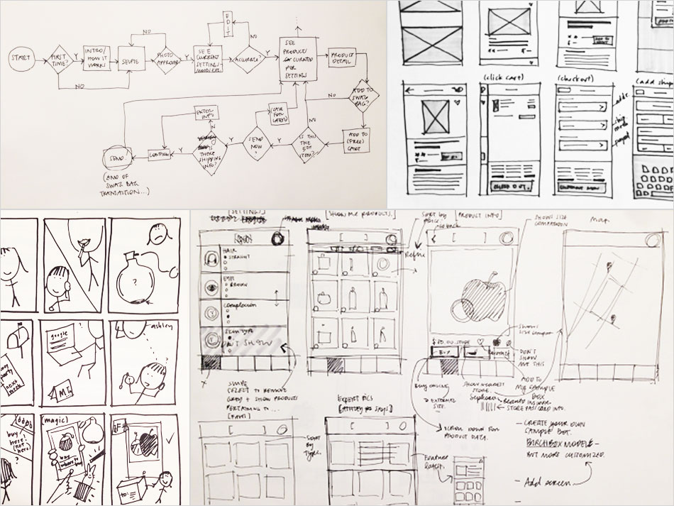

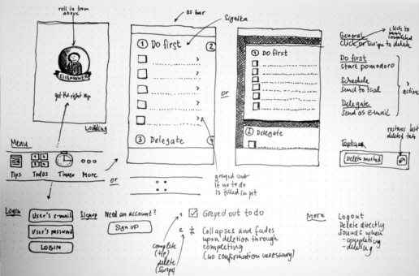

1. Code Design (Class Diagram)

(Class Diagram):

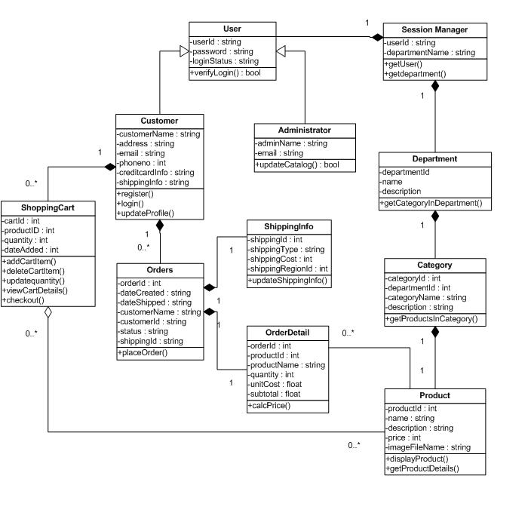

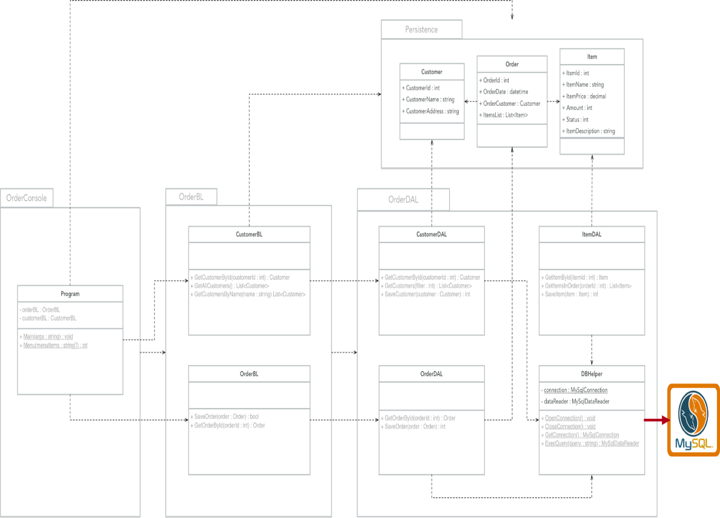

1. Sequence Diagram

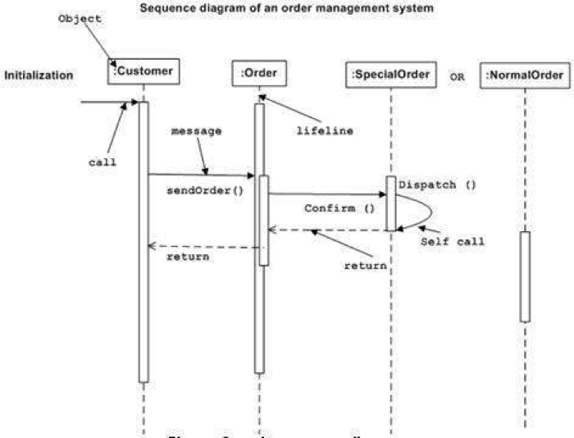

1. Database Design
   1. Entity Relationship Diagram

Or

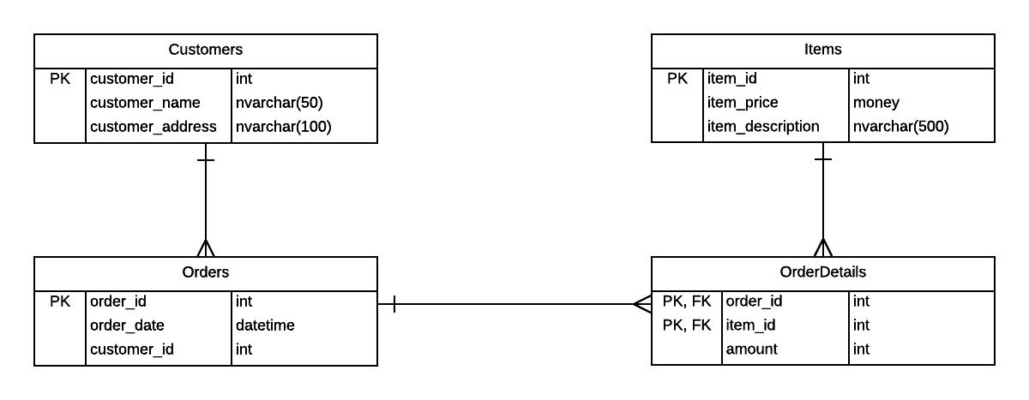

* 1. Database Design Details

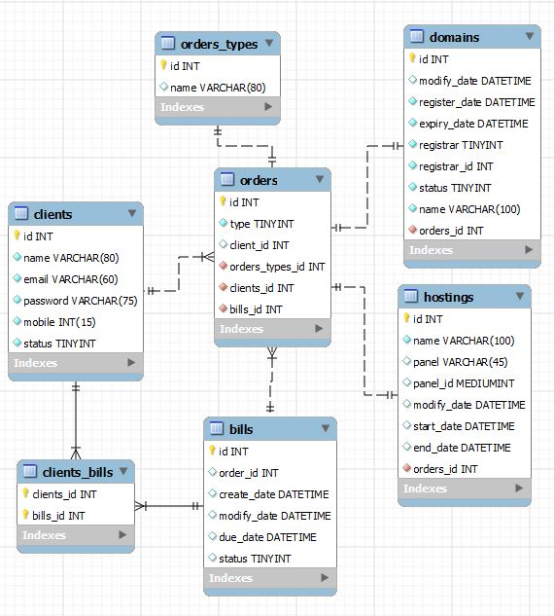

|  |  |  |  |
| --- | --- | --- | --- |
| Users | | | |
| Column Name | Data Type | Constraints | Description |
| UserID | int | Primary Key, Autoincrement |  |
| UserName | varchar(50) | NOT NULL |  |
| UserPassword | varchar(50) | NOT NULL |  |
| FullName | nvarchar(50) | NOT NULL |  |
| Email | varchar(100) | NOT NULL | User Email |
| IsAccountLocked | tinyint | DEFAULT 0 |  |
| IsAdministrator | tinyint | DEFAULT 0 |  |
| DateCreated | Date | DEFAULT | Current Date |

# Test

|  |  |
| --- | --- |
| Test Case Number |  |
| Test Case Name |  |
| Test Case Description |  |
| Preconditions |  |
| Test Case Input |  |
| Test Case Expected Output |  |
| Test Case Steps |  |
| Default Value Preverving |  |

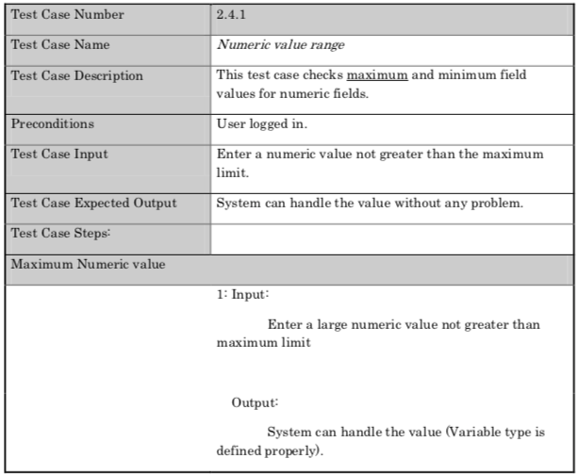

# Task Assign (to each team member)

|  |  |  |  |  |  |  |
| --- | --- | --- | --- | --- | --- | --- |
| Group Name | Project Name | | | | | |
| No | Task name | Description | Start Date | End Date | Member | Self assessment |
| 1 | Write report |  | June 8 |  | Duc & Ly |  |
| 2 |  |  |  |  |  |  |
| 3 |  |  |  |  |  |  |
| 4 |  |  |  |  |  |  |
| 5 |  |  |  |  |  |  |

# Installation Instructions

< Consistently listing conventions when installing software (Detailed instructions with pictures and notes)>

1. Deployment Diagram

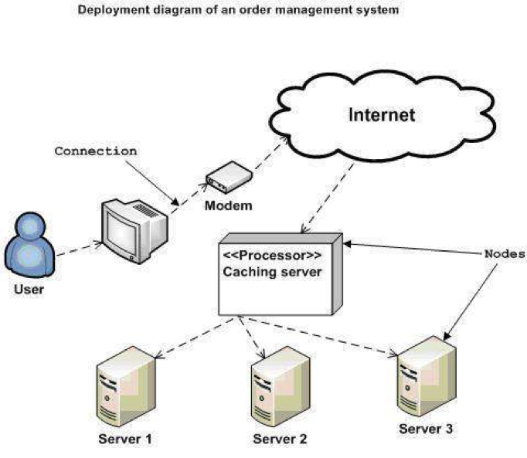

1. Installation steps
   * Database Install
   * Server install
   * Application install

# Appendix

Terms and abbreviations <if available>

<listing terms and abbreviations here>

References <if available >

<List of references here>

Some other issues <if available >

<Results, limitations, experiences, techniques, and other considerations when implementing a project>

# Document format

**Report corver:**

*The cover is printed in blue.*

*With the format as the first page of this document.*

**Paper Size:**

*The report is presented on A4 size paper (210 mm x 297 mm)*

**Top header**

*Left: Logo của VTC Academy*

*Right: Project Name*

*Font: Helvetica Neue (Light) or Arial*

*Font size: 12pt*

**Bottom header**

*Left: Class_Name –Project_Name*

*Right: Page_Number*

*Font: Helvetica Neue (Light) or Arial*

*Font size: 12pt*

**Report Content:**

*Font: Helvetica Neue (Light) or Arial*

*Font size: 12pt*

*Minimum 20 pages*

**Page margin (for A4 size paper)**

*Top: 20 - 25 mm;*

*Bottom: 20 - 25 mm;*

*Left: 30 - 35 mm;*

*Right: 15 - 20 mm;*